To: Dr. S
From: Team 7
Date: March 26, 2021
Subject: Test Result Report

The project is to design a white board robot, this robot will help in writing, reading and scanning the white board. With the advancement in technology, new inventions are developing in the world and people's needs are changing over the time. Now people want to have as many facilities as they can get, and therefore the demand for robots have increased. Robots are used in the educational field. One of the options is to use the robot for operating the white board. Robot will write and clean the whiteboard and scan the board and transmit data over to the website. The writing form will not create a lot of noise and it will clean the board through the soft fabric and it can scan the board with the camera. The scanning cam will roll over the board from one end to the other end.
After the completion of the project, we have a total of eight-point test items, subdivided the content of the twenty-one-point test. The tests were carried out in different fields, such as the robot's hardware precision, functional integrity, control difficulty level and external influence factors of the robot design.
We have 11 inspect tests, 3UTS tests, 2UTM tests and 4 integrate tests, estimated use at least two weeks to test all of them.

Introduction to the System
Our Client is Dr. Kyle Winfree, who is Associate Director for Undergraduate Programs Assistant Professor, School of Informatics, Computing, and Cyber Systems. Dr. Winfree requested we build a robot that is able to write, erase, view, and scan a whiteboard. All of the robot functions need to be usable via the internet so that it can be used from anywhere. Our design to build this robot consists of a polar plotter and an internet-enabled Raspberry Pi. The polar plotter consists of two stepper motors, an Arduino motor controller, and a gondola housing the marker and eraser. The Arduino is plugged into the Raspberry Pi. The Raspberry Pi is used to convert images into gcode, which is sent to the Arduino to control the polar plotter accordingly. The Raspberry Pi is also used to control the robot through the internet via VNC Viewer. This is how the user can draw images, erase the whiteboard, and view the whiteboard (from a camera mounted on top of the whiteboard). See appendix for a current picture of the robot.

System Architecture
Below is a figure of our system architecture. The red arrows and rectangles represent the subsystems we tested.

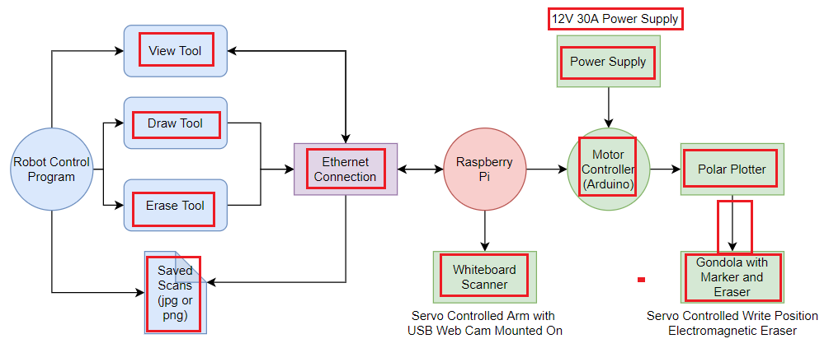

Figure 1: Design Architecture

Requirements, status, type of test
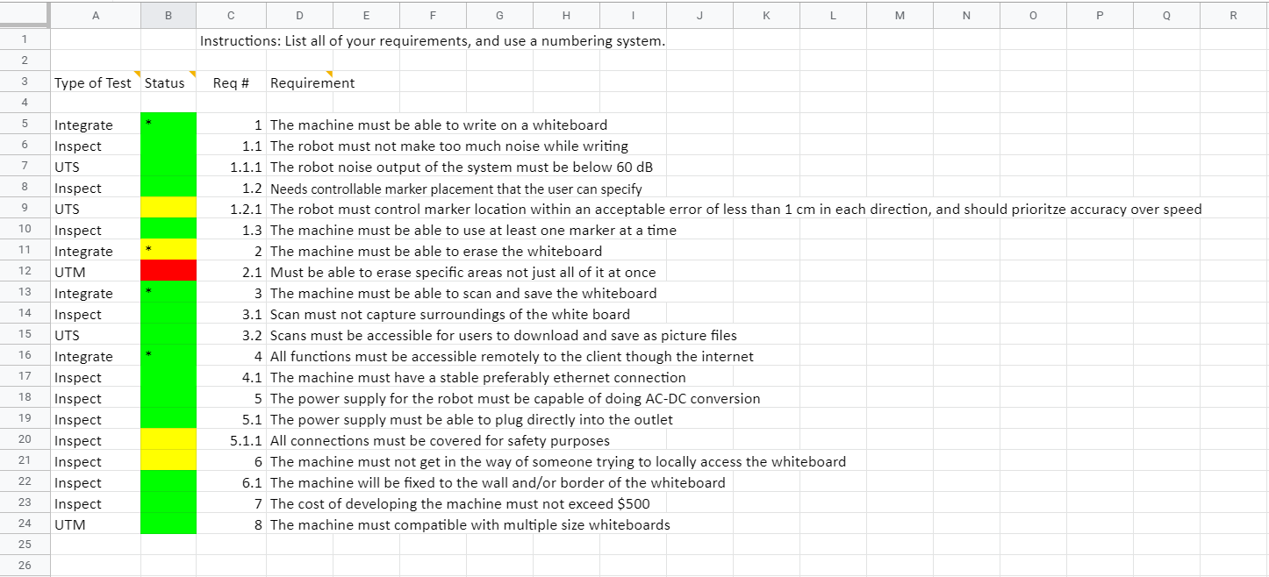
Figure 2: Requirements, status, type of test

Most Important Requirements
Marked with an asterisk are:
1. The machine must be able to write on a whiteboard. This is the most basic part that our robot needs to have. Only if it can write, can it have the additional function behind. If this is not possible, our design is a complete failure.
2. The machine must be able to erase the whiteboard. This is an important additional function of our robot. When we finish writing a whiteboard and need to write new content, this function is necessary. This feature better allows our whiteboard to be used remotely, without the need to wipe the whiteboard. Without this function, our robot would not be as easy to use.
3. The machine must be able to scan and save the whiteboard. This function allows our robot to have the ability see what is on the whiteboard and save it. This let the user know what is already there before starting a drawing and to save it.
4. All functions must be accessible remotely to the client through the internet. The main feature of the robot is it can be used anywhere from the internet. This helps with remote learning and convenience.

Type of Tests
We have 4 types of tests that we performed on the robot. The first type is a unit matrix test (UTM). We used this type of testing when we were testing for the same types of variables and inputs. Each input was expected to yield a certain output, and changing the input should yield a predictable output. We chose UTMs to test the polar plotter positioning, eraser positioning, and testing multiple sized whiteboards. The 2nd type of testing we did is Step by Step testing (UTS). We chose UTS when it made sense to test for different subsystem path execution. We chose UTSs to test the accuracy of the robot, the noise level, and to test the scanning/saving subsystems. The 3rd type of tests we did were inspection tests. We did these tests on requirements that could be visually completed without any procedures. We inspected the cost, the robot mount, the accessibility to the whiteboard, the safety, the power supply, the ethernet connection, the scan captures, the marker usability, having controllable marker placement, and excessive noise. The final type of testing we did was integration testing. We used this type of testing to make sure the subsystems work together the way they are supposed to. We used integration testing to test being able to write on the whiteboard, being able to erase the whiteboard, being able to scan and save the whiteboard, and testing that all functions are usable through the internet.

Major Tests and Analysis of Results
One major test we did was the polar plotter accuracy test. This test is to validate the requirement that the robot draws accurately within 1 cm of the picture. This test was done by generating a 10x10 cm square for the robot to draw. The square was then measured to see if it was within the required accuracy range. The test failed, as the sides of the square were not drawn straight within 1 cm (see appendix for result). This is due to the motors being out of sync. We also noticed that drawing a larger image usually resulted in greater accuracy. Because of this, we suspect the power supply does not always supply enough power. Another major test we did was the noise test. While drawing a sample image, we placed a phone with a noise dB meter 3 feet from the robot. This tested the requirement that the robot not be louder than 60 dB. The robot passed the test, as the loudest recorded noise was 59.3 dB, with the average noise being 53.2 dB. Another major test we did was the integration test of requirements 1, 2, 3, and 4. This tested that all the subsystems worked together so that the robot could write on the whiteboard, scan and save the whiteboard, and erase the whiteboard through the internet. This was done by connecting to the Raspberry Pi through VNC Viewer, uploading a sample image, and drawing it with the robot. Once finished, we scanned and saved the whiteboard, and then erased it. All of these procedures worked except the eraser. Unfortunately, the eraser does not make enough contact with the whiteboard despite having an electromagnet inside. This could be fixed with a stronger electromagnet. Overall, the project performed decently under the testing. Some of the requirements were not met exactly, especially the accuracy of the robot and the erasing mechanism. However we feel that both of these issues could be fixed by using a stronger power supply and redesigning our eraser mechanism.

Lessons learned
Unfortunately, several things went wrong during this project. The power supply we used was not sufficient to properly power the motors, and resulted in accuracy issues. The eraser mechanism was also ineffective. We could improve the project by getting a better power supply and redesigning the eraser mechanism. We also changed several requirements to make them more reasonable. For example, we raised the max noise from 40 dB to 60 dB. We also changed requirements regarding the internet controllability. We originally intended to have an internet browser application to control the robot. However, this turned out to be not necessary and too difficult to implement. We also learned that testing is useful in design, as it shows the flaws that need to be changed.

Appendix

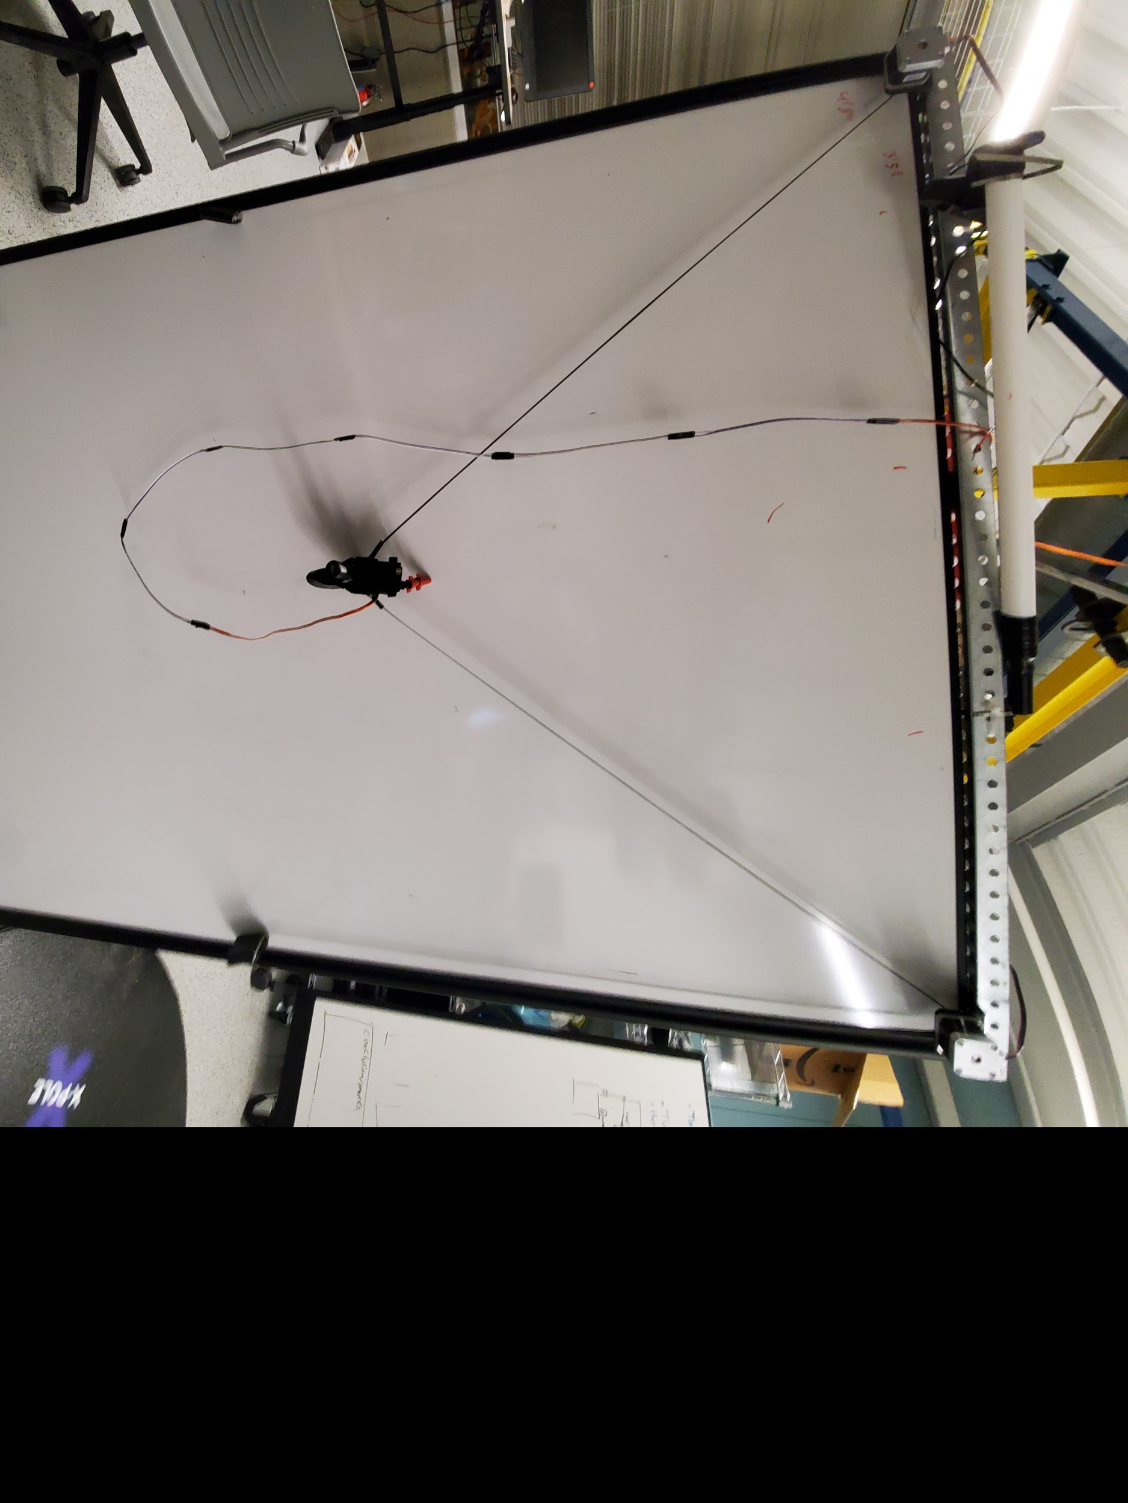
Figure 3: Whiteboard Robot

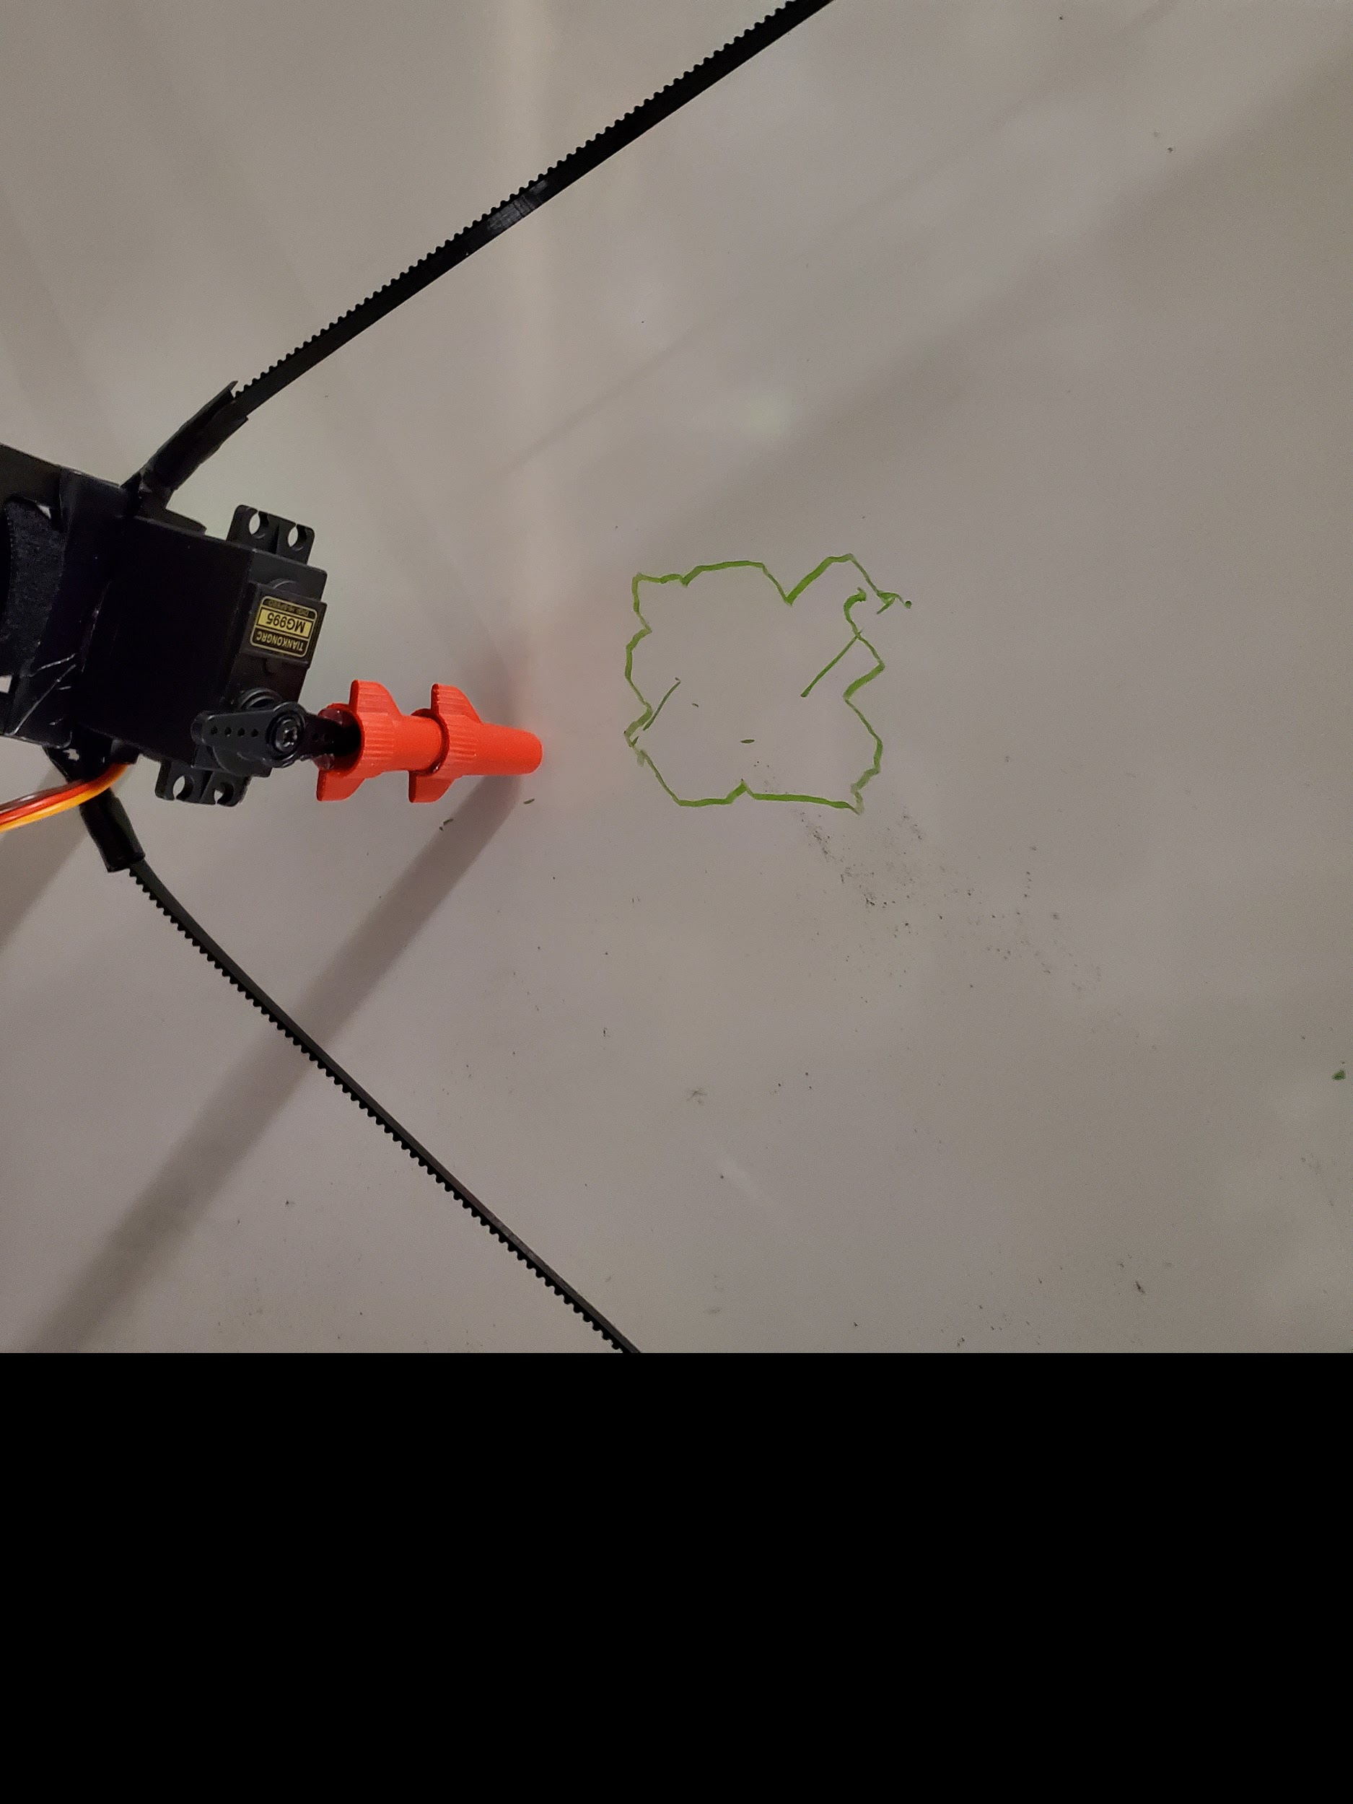
Figure 4: Accuracy Test Results

